Folsom Public Library Georgia Murray Building
411 Stafford Street
Folsom California
Shannon Meaney

LIBR 204-01 Assignment 4

Library Observation

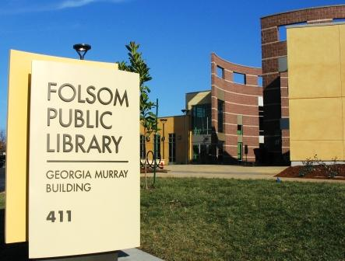
Abstract
I observed the Folsom Public Library located inside the Georgia Murray Building in Folsom California. My observation was conducted on a Saturday March 14th from 1-2:30 pm and Sunday March 15th 10 -11:30am.
Walking into a library I often find myself mentally analyzing its organizational structure and functions related to how it is managed, level of customer service provided, access to their various users, stall morale and job satisfaction, the functionality of its physical layout and design, and how satisfied the users are who use their services. In this paper I will discuss my observation and assessment of the Folsom Public Library. I will address the standards provided, analyze data collected and make a finding.

Folsom Public Library
Community Demographics
The library serves a city of 71,000 residents. It is relatively affluent overall with a medium income of $78,317. There are, however, pockets of poverty. These citizens work in low income jobs that have increased as a percentage of employment in recent years. Another low income group in the community are families of prisoners at the nearby Folsom State Prison. These families relocate from other parts of California to be in proximity with incarcerated members of their families. They live in low income complexes that are near the library observed. Folsom’s population is white (74%), Hispanic/Latino (9%), Asian (7%), Black/ African-American (6%), and Other (4%). There are ethnic groups who needs must be addresses with the largest being the Spanish speaking populations. The education level of the citizens of the community is relatively high 45% have Bachelor’s degree or higher and the expectations for educational attainment and support is also high. In the city of Folsom are ten elementary schools, two middle schools, two high schools and one community college (City of Folsom’s Website 2009).
The Library

The Folsom Public Library serves a rapidly growing city with a rich history dating back to the Gold Rush era. Folsom natives and new residents alike take advantage of the library’s materials, services, and programs for recreation, personal, educational, and professional growth. Library staff places special emphasis on inspiring young children’s interest in, and appreciation for, reading and learning. The library supports students at the elementary and secondary levels while serving as a learning and educational center for all residents of the community. The Folsom Library has over 73,000 items and provides interlibrary loans access for materials from Sacramento County, regional libraries and out of state libraries. It also provides computer technology that consists of internet access, online databases, word processing and an online catalog.
Currently more than 27,000 of the City’s 71,000 residents are Folsom Library card holders. In 2003, the library circulated more than 288,000 items, compared to 97,000 items in 1993. More than 227,000 people visited the library that year, over four times the 55,000 who visited the library during its first year of operation. The Folsom Public Library Georgia Murray Building opened to the public in 2007, followed by the Norman R. Siefkin Public Library in 2008. The Siefkin Library, located on a high school campus, is a joint use library between the City of Folsom and the Folsom Cordova Unified School District. Together the new libraries offer 33,000 square feet of library space and state-of-the-art library services to meet the needs of Folsom residents for many years to come (Folsom Library Website 2009).
Before observation
I chose to observe the main library, the Georgia Murray Building. It is located in a civic center surrounded by surrounded by city buildings, a zoo, a city park and baseball fields. It is located in a mixed socioeconomic area of the city and within a mile of Folsom State Prison. Before entering the Folsom Library I envisioned what I thought the library would be like. In my experience all public libraries are close to the same layout, there is a children’s section, adult section, a place for public computing, reference section and the general collection. To my surprise this library was much different than I expected. Library management did not just build a public library they built a facility that caters to the diverse community for which it serves.
Criteria
Identifying criteria for this assignment I had to contemplate what I thought was important to identify when observing a library. Below is a list of items that I consider to be important when observing the Folsom Public Library’s organizational structure.
Items or characteristics checklist
Facilities/Space
How much space is provided for collections, users, technology, study space, and service desks?
Funding
Where does the library funding come from?
How much is allocated to the library?

Staffing
How much staff was there?
Was there enough staff in the building to service patrons?
Where were they stationed?
What services did they provide?
Ease and Breadth of Access
How accessible was there catalog?
Is the catalog user friendly?
What databases did they provide users?
Did they have wireless access?
Library’s impact on teaching and learning
What kind of a collection did they provide users?
What type of programs did they offer users?
Customers/User Satisfaction
Is the library build to serve its users?
While observing the circulation, where users satisfied with the level of customer service?

Observation
Both days I observed different aspects of the Folsom Library. The first day I began by taking a tour of the facility. When I walked in on my left was the circulation desk, children’s area, teen room, and the public hold shelf. On my right the public computers, self check machine, the reference desk, reference collection, CD and DVD collection, adult collection, and study space.
The second day I watched library users interact with staff, use the technology, use the space and browse the collections. I wanted to see how users interacted with the library and how they used the facility and collections.
On both days I was surprised about the number of users in the facility. The culture of the library seemed very upbeat; there was ongoing interaction by staff and users. Staff was helping patrons and each other when questions arose. It seemed that both staff and users where happy and the flow of the organization seem to be smooth and informal. Users seemed to know how to use the libraries resources and if they had a question they felt at ease when they would approach the circulation desk.

Facility/Space
The first thing I did was walk around the facility to get a good look at the whole space. As I walked through the facility I noted how attractive the various spaces were, bright, attractively designed, and well maintained. I found the library signage was clear, well displayed, and effective (See Image 1 and 2).
I started my walkthrough in the adult area. I found the general collection in the middle of the space with tables and chairs framing the area. When I walked around I was surprised to see how many people occupied the tables and chairs. I saw many users browsing the collection and others using their personal computers that were plugged into outlets located on the table tops.
The library consist of an adult section with reading room attached, children’s area with a story time/picture book room and a teen room that houses all things teen related. I found that the general layout of each area was the same; however each area had a distinct uniqueness about it.
The adult section was what you would expect, housing the general collection of fiction, nonfiction, large print, reference, audiovisual materials, study areas and an information desk. Off to the side of the adult section was an entrance to the reading room (Image 3 and 4). The room was a good size space that included tables and chairs, large comfortable chairs, and a fireplace. It housed newspapers, magazines and a special California book collection. This room provides users with a comfortable reading area to relax and enjoy their library experience.
Upon entering this room you could easily forget you were even in a library setting.
The teen room was like nothing I have ever seen. It was a small room that would interest any teen that enters. It houses two private computers, all the teen magazines a teenager could ask for and a teen book collection. Observing the teens in this room was really interesting, some were on the computer typing away and others were browsing the books and magazines sitting in little couches enjoying their time in the library.
The children’s section was larger than the adult section. The area held the children’s collection of books, 11 computers and a self checkout machine. Connected to the children’s library was the story time room (Picture 5 and 6). The story time room houses the story time area and the picture book collection. I found the picture book collection to be laid out in an effective manner that allows the children to browse the shelves to see which books they would like to borrow. I was also surprised to see how many computers were available for the children. There were 11 computers and one self checkout machine. I thought that this was a great opportunity for children to be able to work on their own in the library, locating items on the computer and researching items they wanted in the library catalog.
The circulation desk was very impressive. The desk was to the left of the entrance and very identifiable. One observation made was that there was no hold shelf behind the desk. The hold shelf was to the left of the desk. It was full of books filled by patron’s last name. When I saw this I thought of two things. One, it looked very messy and two, should users names be out in the open identifying what they were interested in reading? Privacy and having your library look tidy are two things I that have been engrained in my brain. Did management mean for that part of the library to look so disheveled and did they mean for patrons privacy to be compromised?
Folsom’s efficient use of space was very impressive. They used every inch to their advantage. The only problem that I saw was the use of space for public computing (picture 8). The space was compact, close to the entrance, and has no room for growth. In my experience the one thing that grows besides the collection, is the public computing. It looks to me that the computers were an after thought or perhaps a “space available” consideration when planning the space. I feel management could have looked at creating better areas where computers could be housed. To me one of the number one things that draw the pubic into a library is the use of computers. This detail should have been looked at closely by management and should be addressed when looking strategically about space.
Funding
The Folsom Public Library was building in 2007 with a endowment of $13 million dollars. I tried to do a little research on how much the money they city budgets for the library and I was not able to find a current allocation. The friends of the library are a huge organization that brings in funds for the city library. In July they gave the library $80 thousand dollars they raised for the new state of the art security system being installed in the Georgia Murray Library Building.
Labor/Staffing
When I was observing, on both days, I was surprised on how much staffing there was in the building. There was two staff sitting at the circulation desk, one reference librarian at the adult information desk, a reference librarian at the children’s desk, and two people shelving items and placing things on the public hold shelf. I did not expect there to be much staffing on the weekends. Management here must have placed a high priority on customer service and outreach when developing its staffing model.
I found it interesting that none of the staff were wearing nametags. I also noticed when observing the circulation and reference desks that the staff rarely made eye contact with the patrons asking questions, engaged in little dialog, and only one actually walked users to their designated areas explaining how to find something. The staff’s level of service was not anything extraordinary. They answered questions, took calls and helped users with computing questions such as how to use the self check machines and where to find things in the collection.
I found myself asking this question, do they really need this many people staffing the building when they use self check machines? The circulation desk was not that busy, I found that they could have one person staffing the circulation desk and be fully staffed to accommodate patrons.

Ease and Breadth of Access/ Technology
Folsom Library is easily accessible. They have free wireless, public computing, online public catalog and database. Their wireless Internet access is easy to use, and there are adequate and convenient power outlets built into the table and desk tops.
The library has multiple computer workstations equipped with Microsoft Office, Internet access, and electronic databases. Microsoft Office products include Word, Excel, PowerPoint, Publisher, and Access. The electronic databases may also be accessed remotely ( Folsom Website 2009). Computer reservations may be made up to a week in advance and can be used up to one hour per day. Users can make reservations by entering in their library card and PIN information.
The library online catalog is very user friendly (Image 6). Users can search by Keyword, Author, Title, Subject or do an advance search. On the catalog’s page users can also apply for a library card, view the library hours, view other library locations, view the events calendar and browse the online databases. Users may also view their account, renew an item, suggest a purchase and view the catalog in English and Spanish.
Folsom Library subscribes to a variety of on-line databases providing access to consumer resources, general reference, magazines & newspapers, books & reading, and student research materials. Library cardholders can now access these subscription databases from home, work, or any other Internet connection (Folsom Website 2009).
The library subscribes to the 21 databases. These databases included various subject areas including; a repair reference center, animals, consumer health, biography resources center, encyclopedias a free online homework help center for grades 3-12, and more. Library management has provided an extensive collection of databases to meet the need of its community comprised of children, adults, senior citizens, and K-12, junior high, high school, and community college students.
Managing access to a library is very a very difficult process to plan. Copyright and a users right to privacy are two issues that managers must look at when purchasing software and creating access to online collections. At the Folsom library all users must create a library PIN to access databases, electronic books and public computing stations.
Library’s impact on teaching and learning
A public library’s goal is to improve the quality of life and support life-long learning of citizen of the community it serves. In doing so it must also support the teaching and learning goals of other educational institutions. From the observations made and as outlined above I feel Folsom Library provides services that very adequately addresses this goal. In addition to the databases, collections, a wide variety of materials, library catalog and other online resources, the library has adult programs like book clubs and senior Fridays that allow the community to participate in library activities. In addition to the full array of children’s library services they also provide supplemental children programs like homework sessions, kid’s book club, story times and movie times.
Customer/User Satisfaction
Getting the community involved in library activities is very important for a public library. Folsom demonstrates a great example of how libraries should serve their users teaching them how to learn and creating an environment that allows learning to take place. When observing the library I found that users came into the building with a smile on their face and continued to have that smile until the left the building. The library is very user friendly, clean, bright, has a good number of public computing spaces, allows users to have a place where they can sit and relax by a fireplace and has excellent staffing for customer service. The library has encourages reading, browsing and researching. It is a welcoming place for adults, teens and kids alike to enjoy a good book whenever they want.
During my observations I noted that the library users represented the city’s population well. The users represented various income and ethnic groups comprising Folsom. I noted also that users represented all age levels from children to senior citizens. I commend the library planners for providing services and materials that would be of interest to, and could be used by, limited-English speaking and culturally diverse users. I also commend the city planners for locating the library in close proximity to low income users who might lack transportation to use the library. Good strategic planning is evident here.

Management style
Observing the library I want to say that it is a hierarchical bureaucracy organizational structure. A sign of this was the distinct roles that the circulation and reference staff took. They stayed in their locations and did not cross over. Many times I heard circulation desk staff direct users to the reference desk for assistance. I know that many libraries are opting for a single service or floating staffing model within the library environment. San Jose Public Library has revolutionized public library management and customer service models. They have created a model where customers come first. There are not more “roles” to be played. No more circulation, reference and information desks. Staff is encouraged to go around the library and help people as they come. They are encouraged to greet people, ask if they need help and teach users how to use the catalog, browse the collection, do research within the databases and help them check out when they are done (San Jose Public Library Website, 2009).
The San Jose Public Library system has turned their management style around. As Marylin Mason said in our reading,” A public library is just that, the public’s library. It belongs to the community. It does not belong to the director”. A true library serves the community in
which it lives and I believe the Folsom Public Library serves by teaching, housing resources and creating an environment that allows minds to grow.

Findings
I found the Folsom City Library to have excellent resources, staffing, facility and programs for the community. The places where they need to improve are in areas of customer service, user privacy and public computing space.

Image 1 (Library Entrance Signage) Image 2 (Reference Signage)
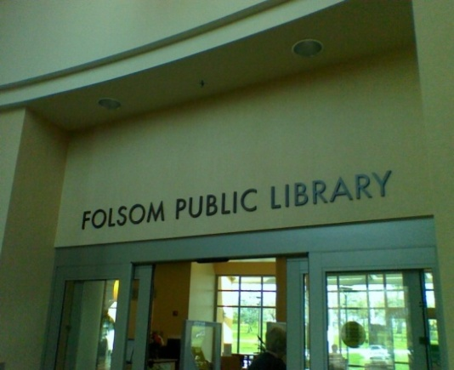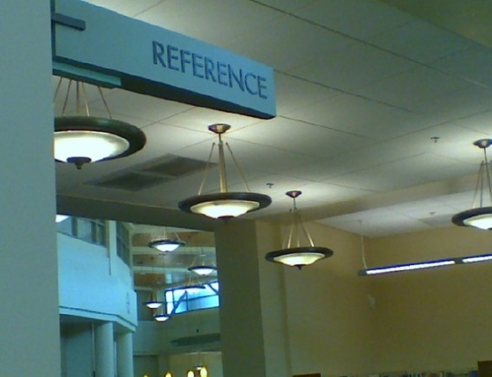

Image 3 (Reading Room Entrance) Image 4 (Reading Room)

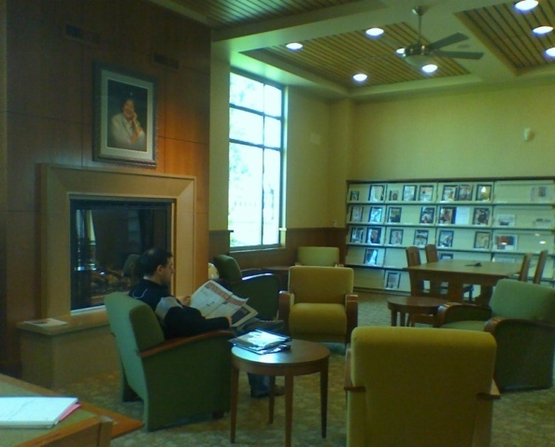
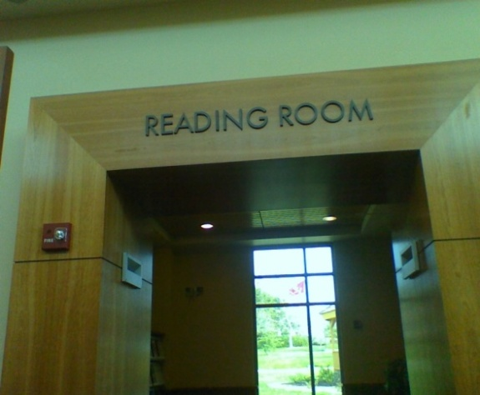

Picture 5 (Children’s collection) Picture 6 (StoryTime RoomP)
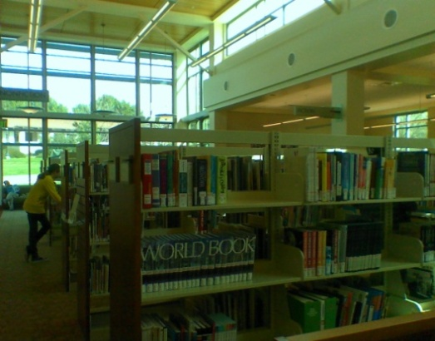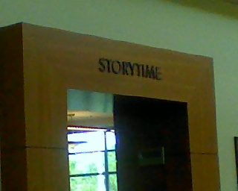

Image 7 ( Childrens Computing Area) Image 8 (Public Computing Area)
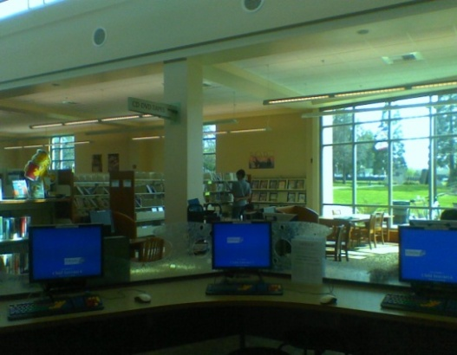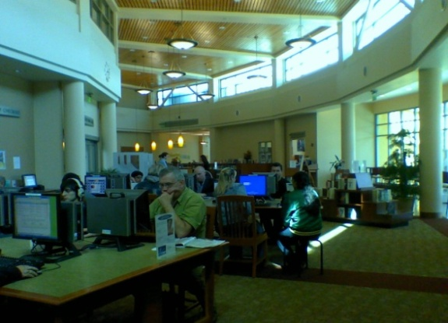

Image 9 (Public Catalog)

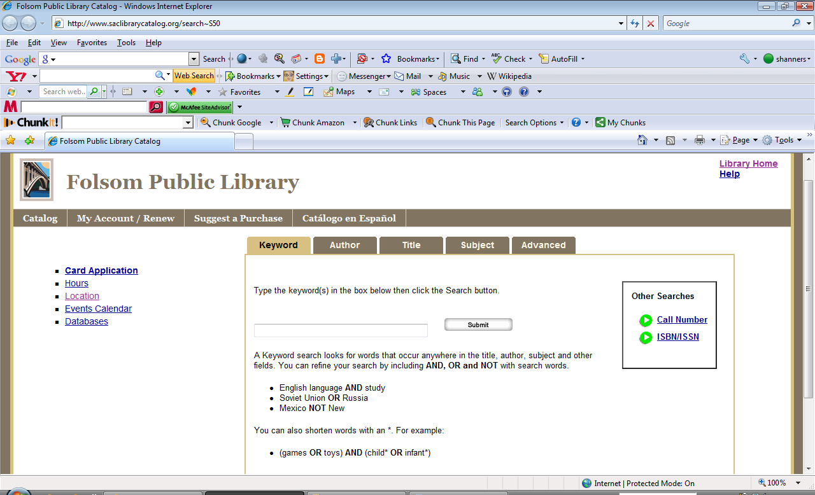

References
Folsom Library Website (2009). Retrieved March 15,2009, from: http://www.folsom.ca.us/depts/library_services/about_the_library.asp
San Jose Public Library Website (2009). Retrieved March 15,2009, from: http://www.sjlibrary.org/about/sjpl/sjway/
City of Folsom’s Website (2009). Retrieved March 15,2009, from: http://www.folsom.ca.us/about/demographics.asp
Friends of the Folsom Library Website (2009). Retrieved March 15,2009, from: http://www.folsom.ca.us/depts/library_services/friends.asp
Mason, Marilyn Gell (1989). Fighting Politics and the public library: A management guide. Library Journal, 15 March, 27-32.

