Team2_Assign3_ServiceEval#18
Meaney, Holmes, & Jones
12 AUG 10
Summer 2010
LIBR 285-01

Running head: LANE MEDICAL LIBRARY WEBSITE

Lane Medical Library Website: From Unusable to Usable
Presented by the Lane Web Team
Shannon Meaney, Tahni Holmes, and Nancy Jones
LIBR 285-01, Ms. Chenoweth
San José State University

Abstract
Since the arrival of the World Wide Web, there has been a critical need for health science libraries to shift from a physical place with print based resources to digital based web access for users. Lane Medical Library is in the process of evaluating and improving its web site to meet its strategic and long-term goals of providing resources for users that are current and usable. This paper will take you through the process by which the Lane Web Team evaluated and analyzed data from peer library reviews and a user wide survey. The results were presented to the Lane Management Team and Lane Strategic Planning Committee for review and implementation.

Lane Medical Library Website: From Unusable to Usable
In a rapidly changing technological environment, it has become increasingly important for medical libraries to meet their strategic mission of meeting users’ needs more effectively by providing a user-friendly web site. Stanford University’s Lane Medical Library serves students, faculty, and staff from Stanford University, the School of Medicine, Stanford Medical Hospitals and Clinics, and the public. Lane's Website, also known as “LaneConnex,” receives 1,151,051 homepage views and 3,428,655 additional web page views a year. LaneConnex is one of the most powerful tools the library has to offer. The site offers users access to information, resources, and library services 24 hours a day, 7 days a week. To ensure the website is meeting user needs, the Lane Medical Library must identify users’ preferences to support their patron's successful web site use. As part of a five year strategic plan based on some preliminary investigation and user feedback, the Lane Management Team assigned the Lane Web Team the task of conducting a website evaluation in order to determine the strengths and weaknesses of their current web site and to make recommendations for improvement.
The Problem: Website Usability
Beginning in 2008, the Lane Management Team implemented a new strategic plan to be executed within the next five years. In May of 2009, the Lane Strategic Planning Committee was created; evaluations were conducted for all areas of the Lane Medical Library. A sub-committee of the Lane Strategic Planning Committee, The Lane Web Team, was charged with redesigning the Lane Library website to increase usability. Web sites are designed as information portals, and the usability of a web site is linked to a variety of factors including: design, organization, and navigation features that assist the user in accessing their information needs. According to usability expert Steve Krung, when people view a website, they don't read the pages in their entirety, they scan them (Kochtanek, 2002). Currently, the website is not functional or user-friendly. Users find it difficult to muddle through tons of content on the site’s homepage in order to find the information they need.
Website Issues
A number of problems exist with the website usability, beginning with the fact that users are not aware that the web site exists or of its full scope and services. Below are some of the issues that users have identified as problems when using the site:
Many Users do not know where to go to find the information they need. Lane’s web pages are too content crowded. Users do now understand how to navigate through the website. The federated search feature is too complex for novice Lane users. Biomedical data is not easily retrieved. The user interface is inefficient, requiring the user to click through too many pages to locate their information needs.
Many users are unaware of the websites full scope of services. Stanford University’s homepage portal is overwhelming. Users are unaware of the site and how to access it from the University’s homepage. The extent of the library’s services is not apparent from the site’s homepage.
Without branding and marketing of Lane’s services, many users are unaware of the site’s features and the Lane Medical Library’s services available to them. Presently, there no clear advertisements being made of library services and programs offered by the library or affiliated organizations. Workshops are not advertised with accurate course descriptions.
Scope of the Analysis
This study aims to address the usability of the website from the users’ perspective in order to redesign and improve the site to better meet user needs. The main issues addressed concerning the usability of the site consist of the following: how to make users more aware of the site and to create a site that is less overwhelming, more functional, and easier to navigate. The evaluations will focus on the website as an information portal and its accessible information services; usability testing will not be conducted on library services that are not linked or only accessed outside of the website.
Does the Answer Already Exist?
The literature contains multiple articles on the subject of website usability. The research and analysis of data brings valuable insights on how to improve a library website to better meet the needs of its users. Prior to a study conducted in 2006, an accepted and systematic method used to evaluate the performance of library technical services department websites did not exist (Mundle et al., 2006). However, Mundle’s study served to validate a proposed model that confirms the use of the performance index (PI) as an objective measure to assess the usability or workability of a catalog department website (Mundle et al., 2006). Used in combination with the developed study tool, the developed model allows for library website comparison based on the PI of a web page with the average PI of 1.5 to ascertain the performance of an individual website (Mundle, et al., 2006).
Another valuable assessment method used for evaluating academic health sciences library websites are focus groups. The School of Medicine at the University of Missouri, Columbia deemed the evaluation method to be fast and cost-effective for obtaining pertinent information as well as a way to make and maintain public relations with their School of Medicine for their web-based curriculum services (Canning, et al., 1995). A number of useful suggestions came out of the four-question focus group study which was applied to the University library’s web-based curriculum services to better meet user needs. As a website coordinator, McKinnell authored an insightful article detailing the negative and positive aspects of developing and maintaining a website in-house –working with a limited budget and technical expertise (McKinnell, 2006). After conducting multiple usability studies over a period of ten years, she learned that websites are in need of continuous evaluation and maintenance (McKinnell, 2006). This article addressed issues relating to website usability from the perspective of a website coordinator which proved to be a helpful resource to our Lane Web Team.
Dee and Allen conducted a multi-tiered academic health science study; however, the results did not provide a clear explanation for the underutilization of academic health science library websites (2006). The researchers’ survey, coordinating online worksheet, and proxy server did however serve as an informative approach to measuring three types of website usability: type and extent of service, navigability, and overall usability of the site (Dee & Allen, 2006). A committee of librarians at the Buffalo University libraries developed a comprehensive evaluation program to test the usability of the university’s website (Battleson, Booth, & Weintrop, 2001). A case study was then performed to determine whether or not the libraries’ users could effectively use the website to perform specific tasks. A formal usability technique involving a “think-aloud protocol,” addressing 11 questions was utilized (Battleson, Booth, & Weintrop, 2001). The test revealed the validity and usefulness of qualitative analysis in website evaluation, and brought to the attention of the committee specifics about the website interfaces that students had difficulty navigating to and from.
Another important case study on the subject of website usability form the user perspective was based on the usability studies used by the Carnegie Mellon Libraries during the redesign of their website for the purpose of identifying several methods of gathering feedback during website redesign or usability testing, because such techniques may be useful to others who are approaching the design and usability testing of their own sites (George, 2005). A web-based survey was used in the case study to determine user needs, proceeding to the prototype design, and completing the process with the final design and usability testing. Think-aloud protocols were also used to determine the strengths and weaknesses of the final design, where participants had the opportunity to verbalize their thoughts as they completed a series of tasks. The results indicated several key weaknesses with respect to navigation, screen design and labeling which lead to more revisions and a delayed release of the library’s new website (George, 2005).
Just as the previous case study noted, several key components of website design are factors affecting the usability of websites by users. In preparation of the University of Pittsburgh’s redesign of the consumer health information website of their health sciences library system, an extensive survey was conducted among consumer health information websites (Ketchum, 2005). The visual survey encompassed 33 consumer health information websites for the purpose of identifying prevalent format and content trends. The findings of the survey yielded a composite webpage of the five most common content and structural features, to include: a one-page scrolling column of links organized by type of information resource, accompanying contact information, a last update notice, disclaimer, and a site search box (Ketchum, 2005). Another comprehensive evaluation of website design that aimed to discover trends in navigational links and make recommended practices for website navigation system design was performed by Brower (2004). Forty-one health sciences websites were evaluated in four specific areas: library general information, website aids and tools, library services, and electronic resources (Brower, 2004). Based on the data collected, a formula was developed for determining obligatory links that listed items that should appear on all academic health science web home pages and persistent navigational tools (Brower, 2004).
Just as the links from the above mentioned analysis project demonstrate a series of best practices for other health science libraries to follow in the design and construction of academic health sciences library websites, so did the results from eight focus groups conducted by the Savitt Medical Library (Henner, & Charles, 2002). The Savitt Medical Library’s evaluation project was funded by the National Network of Libraries of Medicine to improve the use of the internet by health professionals (Henner, & Charles, 2002). Results of the focus group provided a valuable framework upon which to build a successful schema for web site development with public health professionals in mind (Henner, & Charles, 2002). MacCall also understood the importance of meeting clinical information seekers’ needs, and conducted a study to determine the number and topical range of available online medical books and to assess how health sciences libraries were providing access to these resources on their public websites (2006). There were 21 health sciences libraries that comprised the survey, and the results of the study found that minimal efforts are being made of the surveyed health sciences libraries to provide the analytical access necessary to meet the structural needs of clinical information seekers (MacCall, 2006). A valuable point to mention, but not specific to the needs of the Lane Web Team’s website usability focus, this article did constructively emphasize the importance of tailoring website services to meet the specific needs of a user population.
Recommended Analysis
Users of LaneConnex are diverse, and different patron subgroups have very different desires, needs, and capabilities. Both qualitative and quantitative evaluation methods would be helpful in understanding website users’ and potential users’ preferences, and to analyze the usability of the website. The evaluation methods selected by the Lane Web Team will generate the data needed by the Lane Management Team, the Library Director and the Lane Strategic Planning Committee to make informed decisions on how best to improve and customize the site. The evaluation process will start with a comparison of LaneConnex to other peer library websites, and a user survey to measure the usability of the present site. Conducting interviews and holding multiple focus groups would serve as two additional evaluation methods of gathering insightful data about the usability of the website, but due to budget and time constraints, a peer assessment and survey will best serve the Lane Web Team in their pursuit to identify the strengths and weaknesses of the website in terms of its usability to its users.
Peer Library Analysis
The peer library comparison is a quantitative evaluation method that will provide insight into how Lane measures up against comparable academic medical libraries at little cost with limited staff involvement. The Lane Web Team will use the comparison as an opportunity to see how their "peers’" websites organize and link their information services to best meet the usability needs of their users.
User Survey
The user survey is another quantitative evaluation tool that will generate the needed data that will assist the Lane Web Team to establish a profile of the library's users and provide pertinent information on specific areas of the website needing improvements to increase its usability.
Data Collection
This study seeks only information related to the usability of the website and usability of peer library websites for comparison purposes. Data collected during the evaluation process will be analyzed by the Lane Web Team and shared with the Lane Management Team and Lane Strategic Planning Committee for review and direction for making website improvements. Data will not be collected on unrelated topics, such as the Lane Medical Library collection, facilitiesor other Lane Library services that are not offered through LaneConnex.
Peer Library Analysis
For the peer library analysis, the Lane Web Team conducted an environmental scan, and selected five libraries comparable to Stanford’s Lane Medical Library based on a number of demographic data that was gathered from the Association of Academic Health Sciences Libraries (AAHSL). AAHSL supports academic health sciences libraries and directors with benchmarking statistics, partnerships with like-minded organizations, developing a community of colleagues, and much more (Association of Academic Health Sciences Libraries, 2008/2009). Based on similar demographic factors, the five academic medical libraries selected were: Stanford, UCSF, Johns Hopkins, Vanderbilt, and Harvard University. A detailed listing of the medical libraries’ demographic statistics (see figure 1), identify the institutions’ comparable budget size, servicing student population, collection size, in addition to other factors that categorize the university libraries as peers to the Lane Medical Library.
The criteria (see figure 2), used to assess the five library websites was created by Nancy Everhart of St. Johns University. She developed an evaluation scorecard that can be used to rate a library's website with the option of comparing the results of one area over another area using her weighting scheme for benchmarking purposes (Kochtanek, 2002). The total evaluation score is out of 100 points, comprised of evaluation criteria. Sites that reach a score of 60/100 are considered an acceptable website that is of value to a library and its users and is not in need of improvements. Any website that scores less than 40 needs improvement (Kochtanek, 2002).
User Survey
The Lane Web Team created and disseminated a seven question survey to 8,000 students, faculty and staff (see figure 3). The survey was used to collect data associated with the usability of the website from a user’s perspective. The survey is organized into the following sections: Demographics, Evaluations, Strategic Issues and Priorities. It was chosen for its low cost and large impact. The usefulness of the survey depends on the quality of the questions and should cover user’s likes and dislikes about the current website, providing a large amount of data. It will be available for users online and at the service desk in paper form.
Involving Staff
The Lane Strategic Planning Committee and the Lane Management Team will inform Lane Medical Library staff of plans for improving Lane Medical Library services, and specifically, the Lane Web Team’s charge to improve the library’s website at the yearly staff meeting. Communication of the evaluation methods being utilized, time lines and any other pertinent information that would increase support and build public relations with those impacted will be addressed by the Lane Web Team. The Lane Web Team will introduce and explain the peer library analysis and the user survey that will be the evaluation methods of choice for the purpose of improving the library’s website. At that time, staff can volunteer to participate in the evaluation process. Staff will be given opportunities to interact with the Lane Web Team during staff meetings, and their feedback and insights will be received as valuable additions in the website evaluation process.
Conducting the Analysis & Preparing the Report
Assessing the site’s usability was achieved using two evaluation methods: peer library analysis and a user survey. The data collected from both the peer library analysis and user survey were analyzed by the Lane Web Team and compiled into a report with results supporting recommended service improvements as asked by the Lane Management Team and the Lane Strategic Planning Committee. The report reflects a thorough analysis of the site and identifies specific areas of the library’s website needing improvement to increase usability for its users by meeting their design, organization, and navigation needs.
Peer Library Analysis
The peer library analysis began with an environmental scan to determine what academic health sciences libraries would be considered peer libraries to the Lane Medical Library. The five libraries selected were Stanford, UCSF, Johns Hopkins, Vanderbilt, and Harvard, based on sharing similar demographic factors. Using Everhart’s website evaluation scorecard, each library website was evaluated based on the listed criteria of the scorecard and ranked accordingly (see figure 4). The five library website’s scores per the listed criteria on the scorecard were charted for interpretation ease (see figure 5). The sum of each library’s criteria scores were totaled and graphed in another chart, illustrating how Lane Medical Library’s website compares to that of its peer libraries’ websites (see figure 6).
User Survey
The user survey was made available to students, faculty, and staff in both print and electronic format. A diverse population of users participated in the survey, accounting for 8,000 users total, including: faculty, students, nurses, staff, medical fellows/residents/Postdocs, and non-faculty physicians (see figure 7). The raw data collected from the survey (see figure 8 for a sample page) was first compiled into spread sheet format. The data was then analyzed and graphed into a visually pleasing and easy to understand graph, identifying the prominent weaknesses of the Lane website from the user perspective (see figure 9). A final table was produced to summarize the user survey findings, identifying the strengths and weaknesses of the Lane Medical Library’s website (see figure 10).
Executive summary
Lane Medical Library serves students, faculty, and staff from Stanford University, the school of Medicine, Stanford Medical Hospitals and Clinics, and the public. Since the arrival of the World Wide Web, there has been a critical need for health science libraries to shift from a physical place with print based resources to digital based web access for users. The Lane website is one of the most powerful tools the library has to offer users. It is a resources that allows users to be able to access information, resources and services 24 hours a day 7 days a week. When users visit a web site they want ease of use and to find the information they need. The current website is not functional or user friendly, and therefore not meeting the library's strategic or long-term goals of providing users with the information they need. As part of a five year strategic plan, the Lane Management Team, based on some preliminary investigation and user feedback, assigned the web team the task of conducting some evaluations in order to determine the strengths and weaknesses of the current website and make recommendations for improvement. The evaluation process included a peer library analysis and a user wide survey. The data collected is being applied to update and redesign the usability of the website at Lane Medical Library.
Report
The Lane Web Team’s final report synthesizes best practices from both the peer library analysis and user survey that addresses key issues the Lane Web Team would like to make a priority in the Lane Library website’s redesign in the next five years. The following is a list of specific areas of the website needing improvement:
- Create more efficient user interface
- Make available hidden collections Make services more available for view Improve navigation, less clicks
- Design more sophisticated and efficient search strategies for accessing information
- Focus on research development in innovative technology, databases, and search strategies
- Develop more searchable and comprehensive databases that archive all types of scholarly work
Results & Making Service Improvements
The analysis confirmed three types of users: bio-researchers, clinicians and medical students. Based on the results of the evaluations conducted by the Lane Web Team, the Lane Medical Library website will undergo a thorough re-design to improve function and increase content to create a more user-friendly experience for users. Recommended website improvements include: added information and website features, enhanced graphics and layout, and navigable user interfaces, maximizing positive user experiences where accurate information may be found quickly. The usability of the site will be a simplified and more intuitive navigation structure to enhance search capabilities. A help link will be placed on the homepage providing users with access to library staff and services to meet their information needs.
Conclusion
The Lane Strategic Planning Committee and the Lane Management Team have a responsibility to direct the Lane Web Team to design and customize a website that meets the needs of Lane's user population. In order to determine users' current experience with the Lane Medical Library website, a number of qualitative and quantitative evaluation methods were used to analyze the usability of the site with the intention of making website improvements. In a rapidly changing technological environment, it will be necessary for the Lane Medical Library to continue to evaluate and update their website to meet their strategic mission of meeting users’ needs more effectively.

References
Association of Academic Health Sciences Libraries . (2008/2009). Association of Academic Health Sciences Libraries . Retrieved 07 27, 2010, from Annual Statistics of Medical School Libraries in the United States and Canada: http://www.aahsl.org/mc/page.do?sitePageId=86427&orgId=aahsl
Battleson, B., Booth, A., & Weintrop, J. (2001). Usability testing of an academic library website: A case study. The Journal of Academic Librarianship, 27(3), 188-198.
Brower, S. M. (2004). Academic health sciences library Website navigation: an analysis of forty one Websites and their navigation tools. Journal of the Medical Library Association, 94(4), 412-420.
Canning, C. S., Edwards, A., Meadows, S.E., & Lottes, J. (1995). Using focus groups to evaluate library services in a problem-based learning curriculum. Medical Reference Services Quarterly, 14(3), 75-81. doi:10.1300/J115V14N03_08
Dee, C., & Allen, M. (2006). A survey of the usability of digital, reference services on academic health science library web sites. The Journal of Academic Librarianship V.32 No.1 (January 2006) P. 69-78, 32(1), 69-78.
George, C. A. (2005). Usability testing and design of a library Website: an iterative approach. OCLC Systems and Services, 21(3), 167-180.
Henner, T. A., & Charles, P. (2002). Using focus groups to guide development of a public health web site. Medical Reference Services Quarterly V.21 No.4 (2002) P.15.
Ketchum, A. M. (2005). Consumer health information Websites: a survey of design elements found in sites developed in academic environments. Journal of the Medical Library Association, 93(4), 496-499.
Kochtanek, Thomas R., Matthews, Joseph R. library Information Systems. Westport, CT: Libraries Unlimited.
Matthews, J. (2007). The Evaluation and Measurement of Library Services. Westport, CT:
Libraries Unlimited.
MacCall, S. L. (2006). Online medical books: their availability and an assessment of how health sciences libraries provide access on the public Websites. Journal of the Medical Library Association, 94(1), 75-80.
McKinnell, J. (2006) Be careful what you wish for: Do more resources and tools make a web site better?. Online (Weston, Conn.) V. 30 No.2 (March/April 2006) P. 33-7, 30(2), 33 37.
Mundle, K., et al. (2006). ARL Library Catalog Department Web Sites: An Evaluative Study. Library Resources & Technical Services, 50(3), 173-185.

Figure 1: 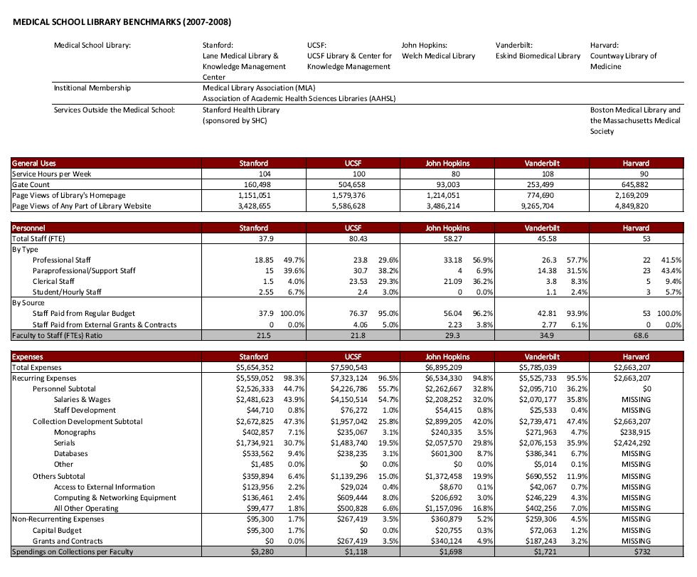Environmental Scan of 5 Peer Libraries’ Demographic Statistics

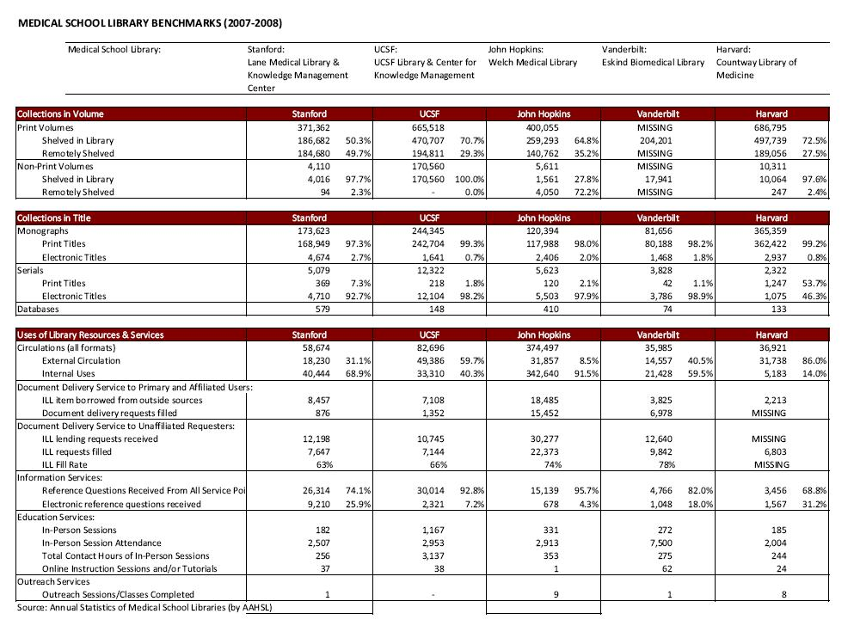

Figure 2: Nancy Everhart’s Website Usability Scorecard

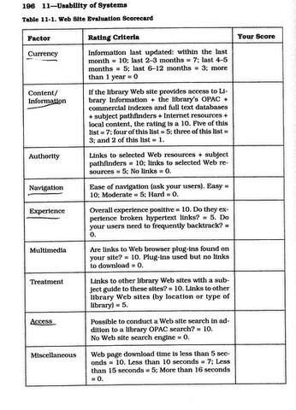

Figure 3: User Survey

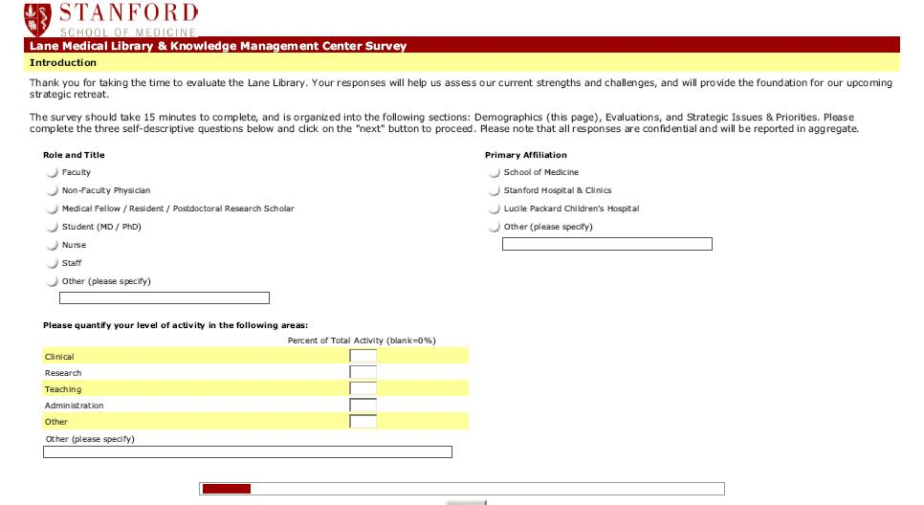

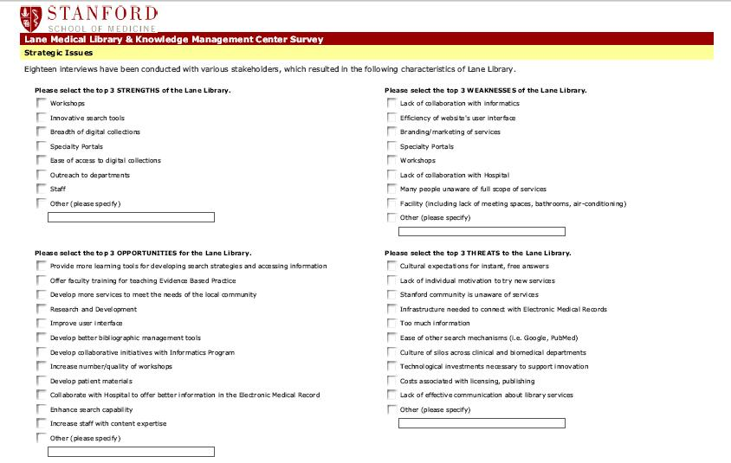

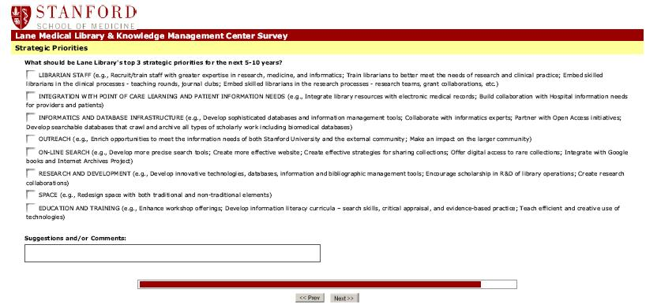

Figure 4: Peer Library Analysis Data
Factor | Rating Criteria | Stanford | UCSF | Johns Hopkins | Vanderbilt | Harvard
Currency | Information last updated:  Within the last month = 10; last 2-3 months = 7; last 4-5 months = 5; last 6-12 months = 3; and more than 1 year = 0 | 7 | 7 | 5 | 7 | 0
Content/  Information | If the library website provides access to library information + the library’s OPAC + commercial indexes and full text databases + subject pathfinders + Internet resources + local content, the rating is a 10; five of the list = 7; four of the list = 5; three of the list = 3; and two of the list = 1 | 10 | 10 | 7 | 10 | 10
Authority | Links to selected web resources + subject pathfinders = 10; links to selected web resources = 5; and no links = 0 | 10 | 10 | 5 | 10 | 10
Navigation | Ease of navigation:  Easy = 10; moderate = 5; and hard = 0 | 10 | 10 | 5 | 5 | 5
Experiences | Overall experience positive = 10; do they experience broken hypertext links? = 5; and do your users need to frequently backtrack? = 0 | 10 | 10 | 5 | 5 | 5
Multimedia | Are links to web browser plug-ins found on your site = 10; 5; plug-ins used but no links to download = 0 | 10 | 5 | 5 | 5 | 5
Treatment | Links to other library websites with a subject guide to these sites? = 10; links to other library websites (by location or type of library) = 5; none = 0 | 10 | 10 | 5 | 10 | 10
Access | Possible to conduct a website search in addition to a library OPAC search? = 10; 5; no website search engine = 0 | 10 | 10 | 5 | 5 | 10
Misc. | Web page download time is less than 5 seconds = 10; less than 10 seconds = 7; less than 15 seconds = 5; and more than 16 seconds = 0 | 10 | 10 | 10 | 7 | 10

Figure 5: Peer Library Analysis Data

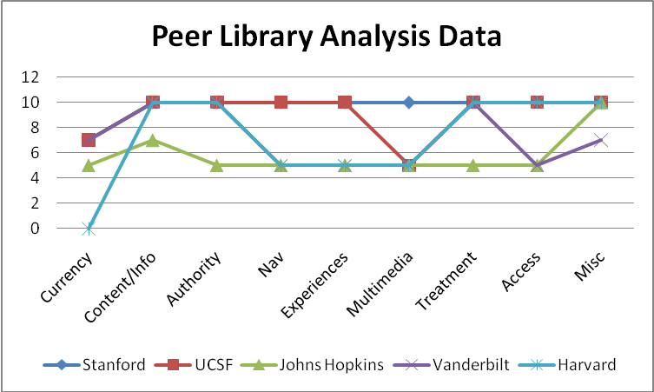

Figure 6: Overall Peer Library Scores

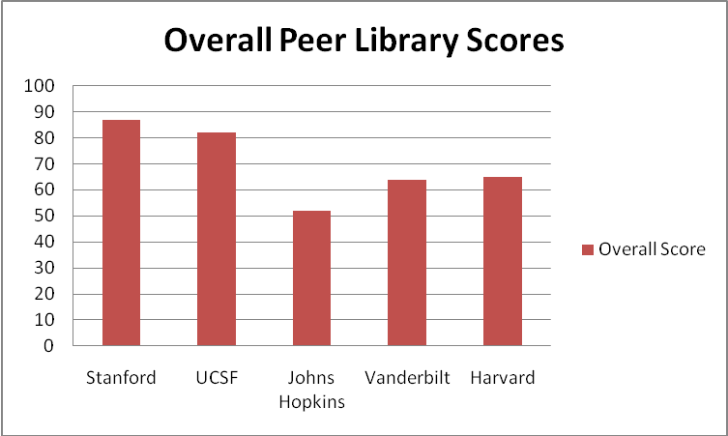

Figure 7: User Survey Participant Population
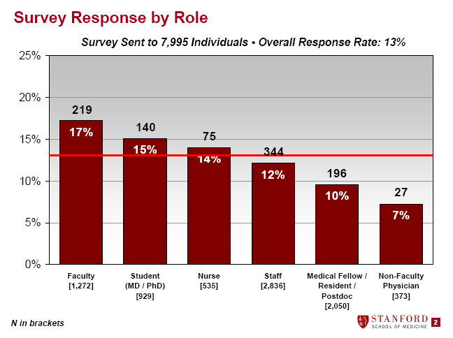

Figure 8: Sample of Raw Data from User Survey

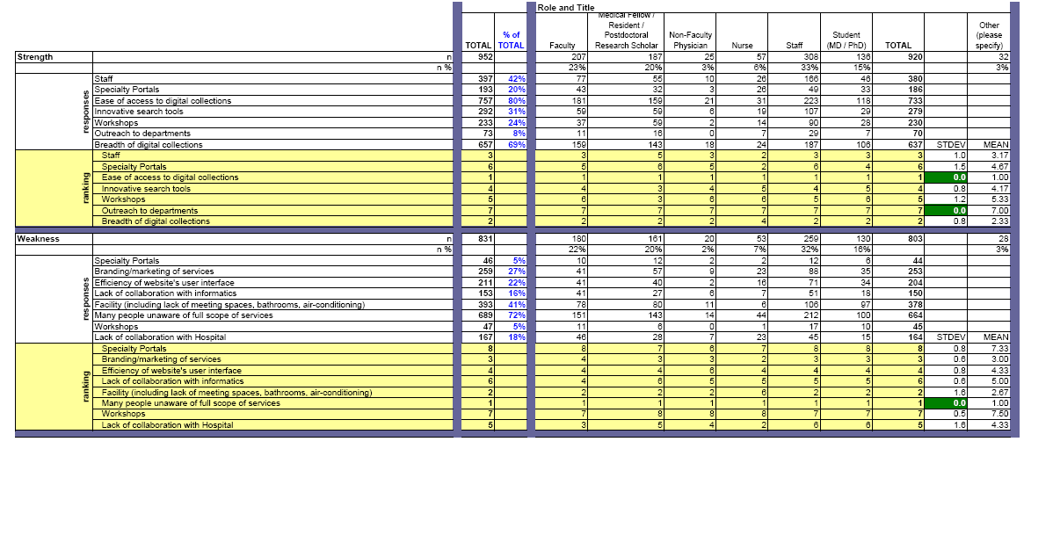

Figure 9: Lane Library Website Weaknesses

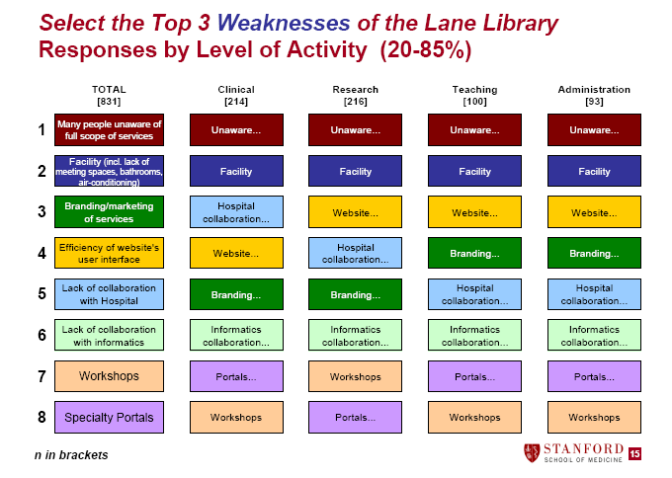

- Rarely use portals (3) (Easier and more precise to go through publisher sites; go directly to PubMed; go to Google)
- Portal is overwhelming
- Biomedical data not easily retrieved
- Not leaders in Biomedical information
- Difficult to find patient education materials
- Efficiency of user interface – too many pages to click through (3)
- Lack of resources targeted to nurses
- Unaware of LaneConnex
- Unaware of portals
- Advertise workshops with more accurate course descriptions
- Unclear access for Adjunct clinical faculty and staff physicians
- Branding – not a knowledge management center
- Lack of resources for non-English speaking faculty and postdocs

Figure 10: SWOTS



